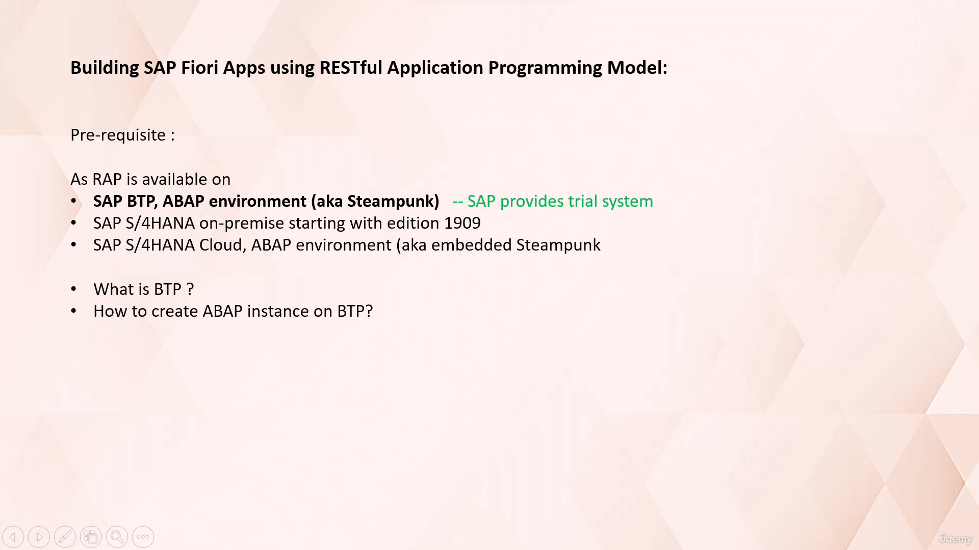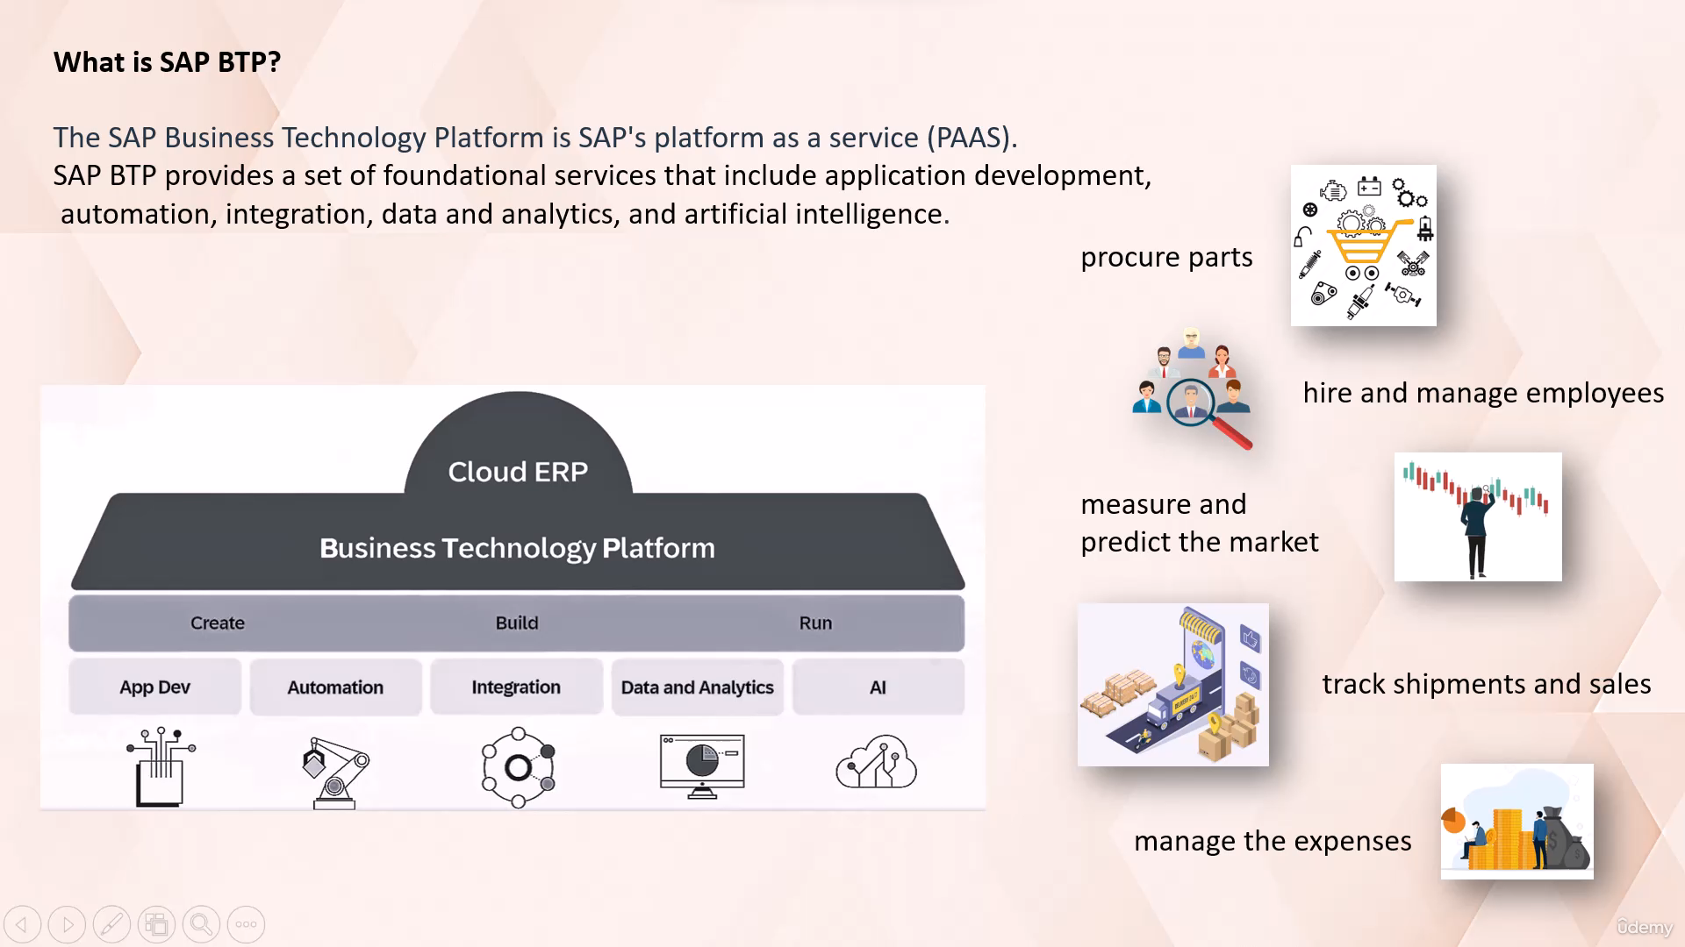That's where ACP BTP platform comes in.

SAP BTP provides an intelligent platform as a service to connect both SAP and Non-sap applications to

the cloud based infrastructure to get the most out of your application.

And it allows the necessary transformations to keep up with the fast paced business landscape.

SAP BTP provides different solutions for development, automation, integration, analytics and new

age technologies.

SAP BTP provides different development environments to build applications required for the business.

You could automate processes such as procurement and shipping, which will save you time and resources.

It provides APIs to connect to the other providers and their systems, such as company that ships you

raw materials.

You can visualize market trends with the meaningful dashboards to help make quick decisions based on

the real time sales data.

You can also improve the customer shopping experience by using AI to help with picking the best car.

So basically, it provides the tools required to build and run business applications all through one

single cloud based platform.

So I hope with this example you understood what is PDP and its capabilities.

That's it for now.

In the next video we will see how to create the Abap instance or BTP.